**Georgina’s Restaurant Brief:**

Colors: Dark colors, copper, warm colors

Accent colors: Red

Style: elegant, classy, fine dining

Restaurant Name: Georgina’s

-Fusion Cuisine

-Authentic Asian & Latin Taqueria

**Navigation:** Reservations, Menu, Private Events, About Us, Gallery, Contact,

**Logo:** We don’t have the logo files, so the logo may need to be created for this project.

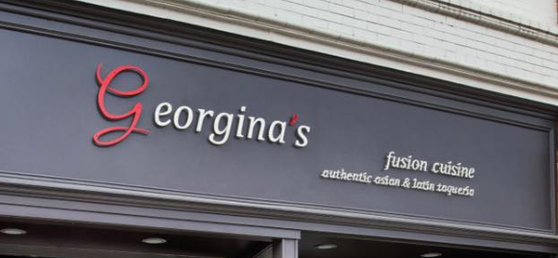

**Header Text:** Georgina’s

**Sub text:** Fusion Cuisine

**Additional Sub text:** Authentic Asian & Latin Taqueria

**Button:** Make Reservation

**Menu: (**see attached images)

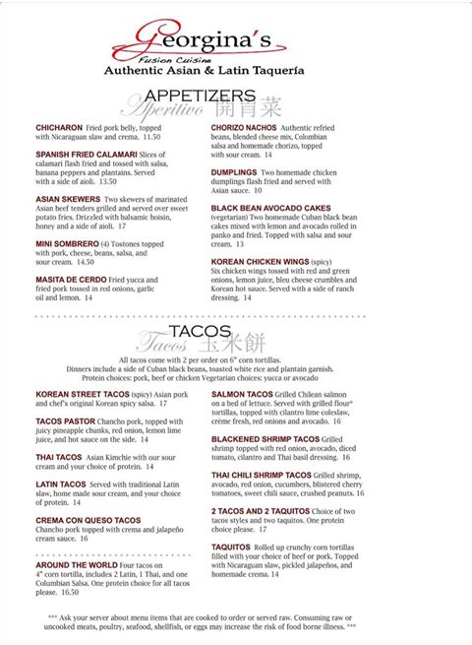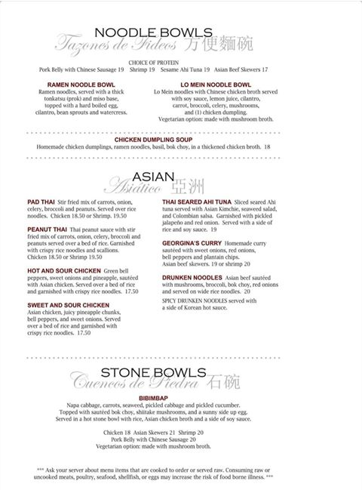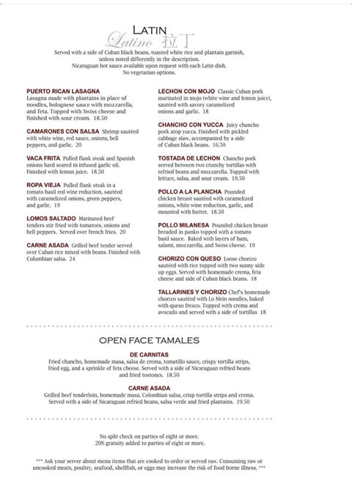

**Additional Pictures:**

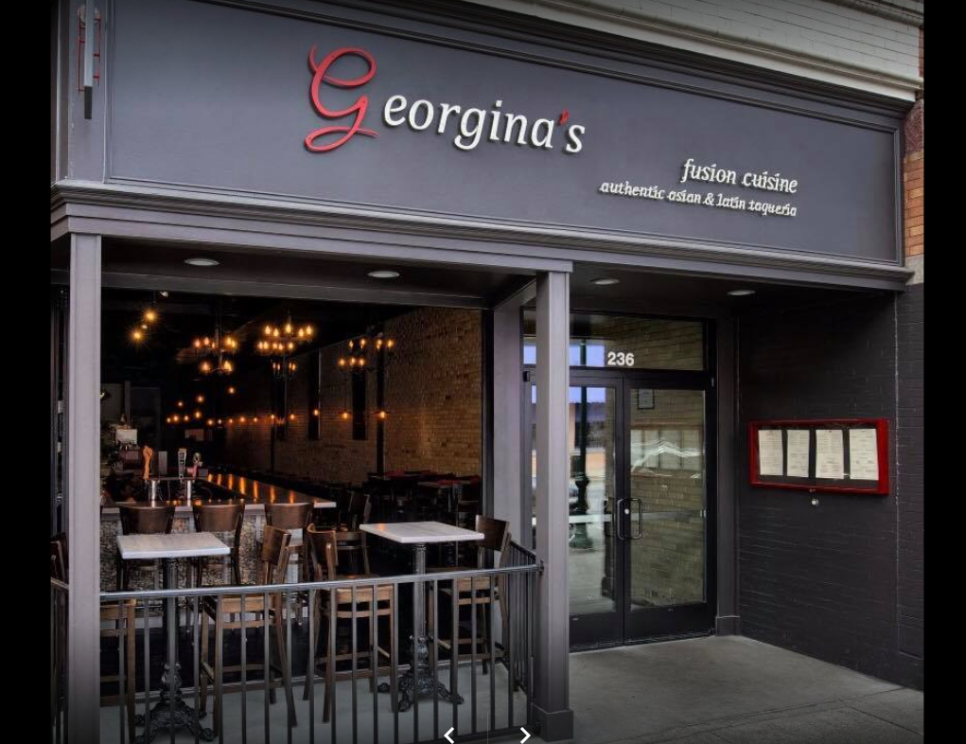

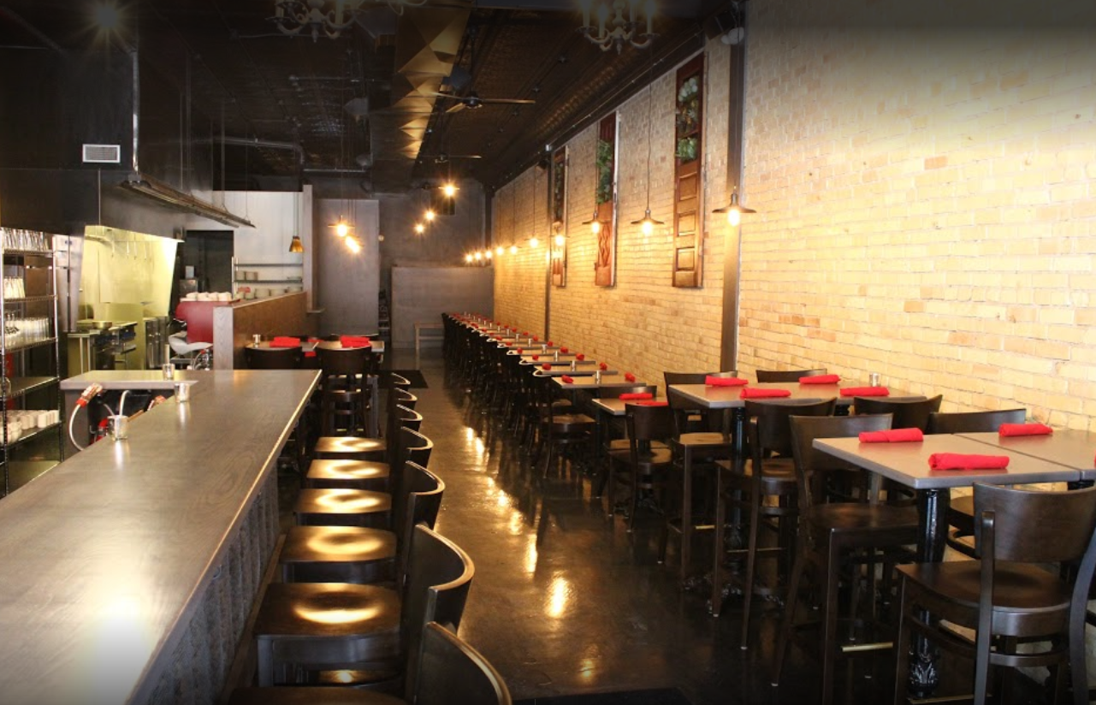 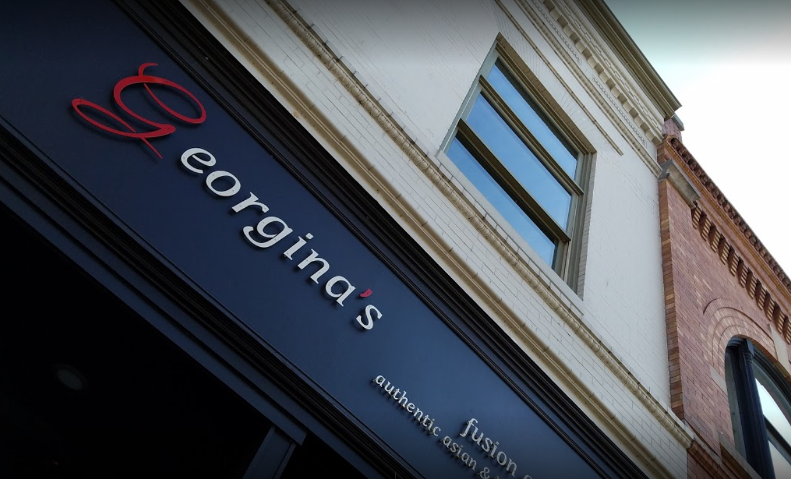 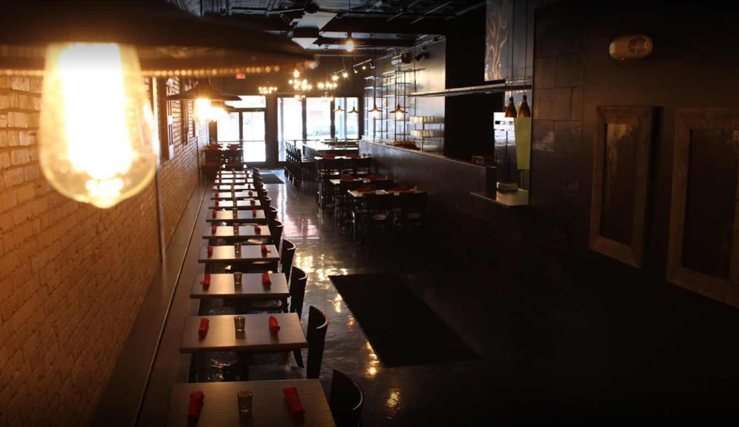 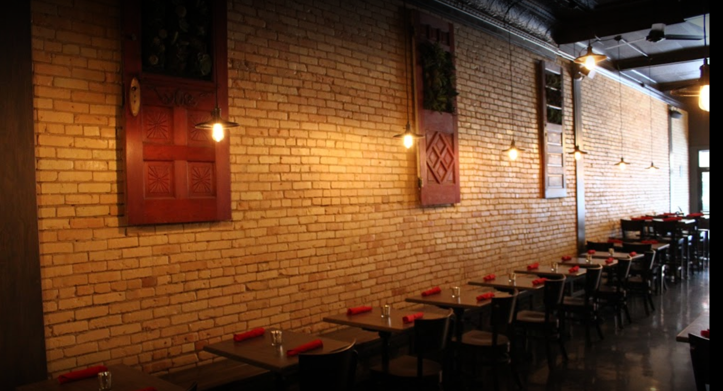 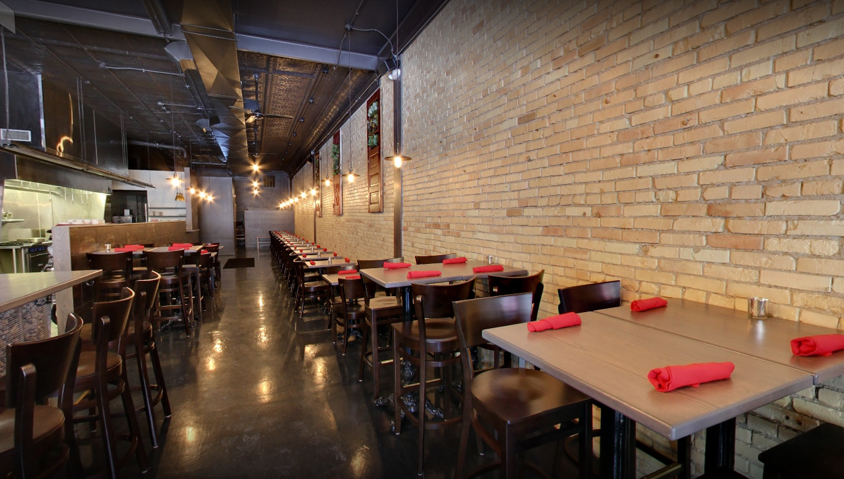

**About us:**

Chef

Antonia Craig

Antonio Was taught to “love a dish for what it is! The ingredients are the flavor of a dish; they make the dish better.” He shares, “In America, we eat with our eyes, but it's our taste buds that will not lie to us.”

Antonio remembers always being around food, but he didn't start cooking until he was almost 10 or 11 years old. He was born and raised in Bluefields, Nicaragua, where his mom, Elsie, had a restaurant. She initially taught him how to cook. Elsie loves to cook and bake herself and according to Antonio, she is the great cook.

Mealtime was important growing up. “Everyone sat at the table together. If the phone rang, no one answered it, and the TV was always off. It was a special time to sit together and experience the meal. Food is great and beautiful and should be enjoyed.”

Cooking definitely runs in the family. Antonio was called “Champion” by the guests in both his mother’s and his uncle’s restaurants, where he spent a lot of time in growing up. His sister, Sofia, learned how to bake from his mother and although she is a nurse, she has a passion for baking. Antonio, instead, paid close attention to the meals his mother and uncle created, and learned how to cook meals influenced from different backgrounds. His uncle's restaurant was 100% Chinese and Elsie is Chinese Nicaraguan. Antonio learned how to cook lobster, steak, shrimp and various Spanish and Chinese dishes from his mother.

When Antonio was 17 years old, he worked in Tampa, Florida, at the second oldest Outback Steakhouse restaurant. He recalls, “we were super busy and the love for cooking came naturally. I knew then, at 17, that I loved to cook; it was my passion.”

Antonio opened his first restaurant, Georgina’s Fusion Cuisine, in 2013 in a tiny building at 439 E Front Street., in Traverse City, MI. The day after Thanksgiving in 2014, he moved across the street to a much larger location directly across from the State Theater at 236 E. Front Street. Since then, his menu has expanded, and he has added a full bar.

Still, whenever Antonio has a question about an ingredient, he calls his mom. A meal is a wonderful way of combining each ingredient together and you simply have to experience the prepared meal by tasting it.